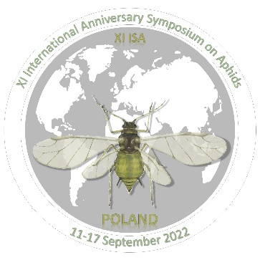
XI ANNIVERSARY INTERNATIONAL SYMPOSIUM ON APHIDS
Katowice-Targanice, 11-17.09.2021

REGISTRATION FORM
Full participant

1 | Name:
2 | Surname:
3 | e-mail:
4 | Institution:
5 | Address:
6 | Country:
7 | Oral speech*
8 | Poster*
9 | Vegan menu:
10 | Allergies:
11 | Invoice info:

Oral speech **
Title:
Authors:
Presenting author:

Poster ***
Title:
Authors:
Presenting author:

* please indicate by X which kind of contribution you plan to present (one or both)
** if you plan to give more speeches please copy the table
*** if you plan to present more posters please copy the table

